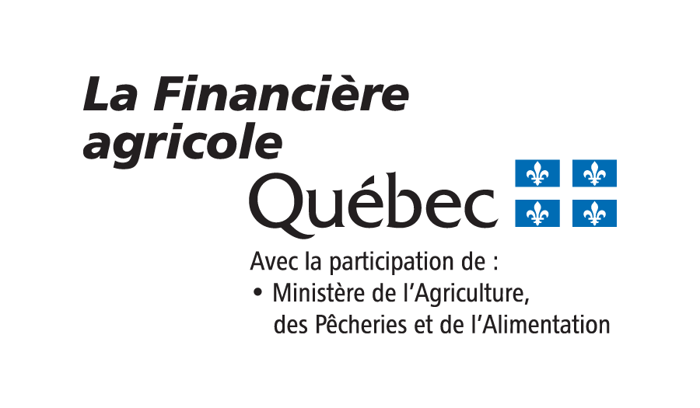

PROGRAM TO SUPPORT DIVERSIFICATION AND REGIONAL DEVELOPMENT
Application to Participate

 |  | Reserved for the FADQ (FADQ Client No.) |  | Ministerial Identification No. (NIM) |  |  | Québec Business No. (NEQ)
1 | Business Information
Name or business name |  |  |  |  |  |  |  |  | Pone No. (Home)
Business e-mail |  |  |  |  |  |  |  |  | Phone No. (Cell)
Production site address (House No. and street name) |  |  | Municipality |  | Postal code |  |  |  | Phone No. (Other)
Correspondence address (House no. and street name), if different |  |  | Municipality |  | Postal code |  |  |  | Fax No.
RCM of production location |  |  | Do you currently have an outstanding loan guaranteed by the FADQ or did you obtain a grant from the FADQ in the last 5 years? |  |  |  |  | YES
 |  |  |  |  |  |  |  | NO

2 | Program Components and Eligibility Requirements
The Program to Support Diversification and Regional Development has three components: Diversification Support, Land Improvement Support, Support for Greenhouse Operations and Support for Milk-Fed Calf Operations. To be eligible for the financial support offered by La Financière agricole du Québec, farm businesses must satisfy the eligibility criteria of at least one of the Program’s components.
- Please select the component(s) for which you are applying and complete the related section.
- Select the description that matches your operation’s reality: |  |  |  | - Select one or several investment projects you would like to carry out through this program:
 |  | COMPONENT 1: Diversification Support
 |  |  | Existing farm business |  |  | Diversification – Agri-tourism
 |  |  | Existing business in agro processing |  |  | Diversification - Processing
 |  |  | Goods and services company, 50 % or more of which is owned by persons engaged in agriculture |  |  | Organic certification
 |  |  | New business with a gross farm income of at least $30,000, at least 36 months after the project’s implementation |  |  | Development of a new production
 |  |  |  |  |  | Increase in productivity
 |  | COMPONENT 2: Land Improvement Support
 |  |  | Project located in one of the RCMs deemed a priority by MAPAQ (see Appendix 1) |  |  | Drainage
 |  |  | Existing farm business |  |  | Replanting of fallow land
 |  |  | New business with a gross farm income of at least $30,000, at least 36 months after the project’s implementation |  |  | Major soil acidity correction
 |  |  |  |  |  | Other:
 |  | COMPONENT 3: Support for Greenhouse Operations
 |  |  | Existing business |  |  | Development of a production
 |  |  | New business with a gross farm income of at least $30,000, at least 36 months after the project’s implementation |  |  | Increase in productivity

 | COMPONENT 4: Support for Milk-Fed Calf Operations
 |  | Existing business |  |  | Production reorientation
 |  |  |  |  | Increase in productivity
 |  |  |  |  | Loan consolidation guaranteed by the FADQ
 |  |  |  |  | Other:

3 | Investment Projects
- Please summarize your project(s) in detail by indicating the nature of the required investments, the total cost of the project(s) and the amount of the loan requested from the FADQ.
Nature and description |  | Cost or estimate | Requested loan
 |  | $ | $
 |  | $ | $
 |  | $ | $
 |  | $ | $
 |  | $ | $
 |  | $ | $
TOTAL |  | $ | $

4 | Documents Required
COMPONENT 1, COMPONENT 3 and COMPONENT 4 |  |  | COMPONENT 2
 |  | Business or marketing plan describing the project |  |  | Analysis prepared by an advisor
 |  | Application for Financing/Global Investment Plan (Form 1002) |  |  | Plan prepared by an engineer, if required
 |  | Recent financial statements (last 12 months) |  |  | Partial budget prepared by an advisor
 |  | Individual sheet (Form 1001) for each participant in the business (new FADQ clients only) |  |  | Application for Financing/Global Investment Plan  (Form 1002)
 |  | Action plan and analysis to justify future investments |  |  | Recent financial statements (last 12 months)
 |  |  |  |  | Individual sheet (Form 1001) for each participant in the business (new FADQ clients only)

5 | Statements and Commitment
- In the framework of my participation in the program for one or other of the components that are provided, I agree to allow the Ministère de l’Agriculture, des Pêcheries et de l’Alimentation du Québec to conduct a follow-up of the authorized project for at least the first three years of its implementation.
- In the framework of Component 1, Component 3 and Component 4 of the program, I agree to obtain support services if La Financière agricole deems it necessary.
- I agree to submit, every year, my operation’s financial statements for the fiscal period to the La Financière agricole du Québec financial advisor.
- I declare that all of the information provided in this application, financial or otherwise, is accurate and complete.
 |  | Representative’s name in block letters
 |  | Representative’s signature | Date

6 | Applicant’s Consent
CONTEXT
In administering the Program to Support Diversification and Regional Development, La Financière agricole du Québec only collects the information required to study your application for participation. This information is vital to running the program and only the necessary data will be used for this purpose. La Financière agricole du Québec remains, at all times, the holder of the personal information collected during the course of this program.
However, given that the Ministère de l’Agriculture, des Pêcheries et de l’Alimentation du Québec (MAPAQ) is an integral part of the program, notably in the follow-up of the projects, the information and documents collected in the framework of your application for participation and financing must be passed on to MAPAQ. To this end, your signature is required on the following statement of consent.
CONSENT
I, the undersigned,________________________________________________________, duly qualified representative of business______________________________________________________________________________________,
authorize La Financière agricole to give MAPAQ the information and documents it has collected and which are needed to follow up my project and administer the Program to Support Diversification and Regional Development.
This consent is valid for the duration of the Program to Support Diversification and Regional Development and will end when the last investment grant payment is made, at the latest 3 years after the full disbursement of the loan or $15,000 of investment grant.
 | Representative’s name in block letters
 | Representative’s signature | Date

7 | Disclosure of Personal Information
The personal information collected by La Financière agricole will be treated confidentially and will only be disclosed to authorized persons or organizations, according to the provisions of the Act respecting Access to documents held by public bodies and the Protection of personal information, R.S.Q., Chapter 2.1).

